PB TD Bank Account Wed July 17, 2019 820 PM Bal = $ 15,302.80

Quicken Bal after data transfer $ 15,367.80

Diff $65.00 see May 11 2019 manual deposit for St. Andrew’s Nursery spring show ad for both spring show and 2019 holiday show. To fix this I just need to perform another data transfer from TD into Quicken and then physically enter a click to create a check mark so this specific entry will be accepted as a cleared transaction in Quicken.

Note the $268.58 balance adjustment to get Quicken into balance with the TD online balance.

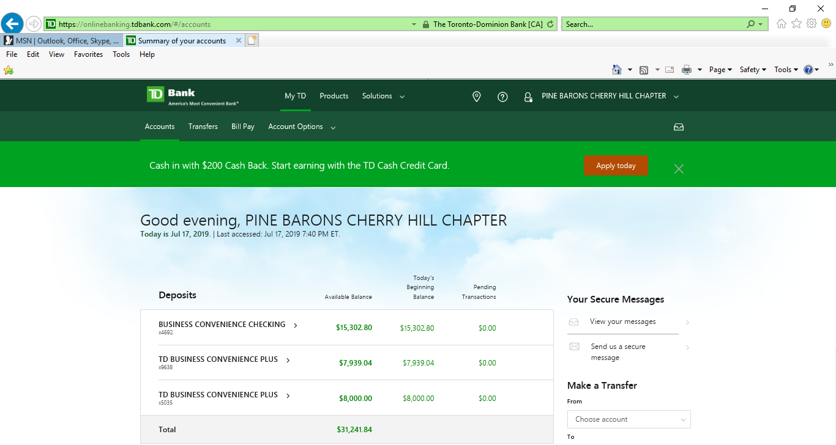

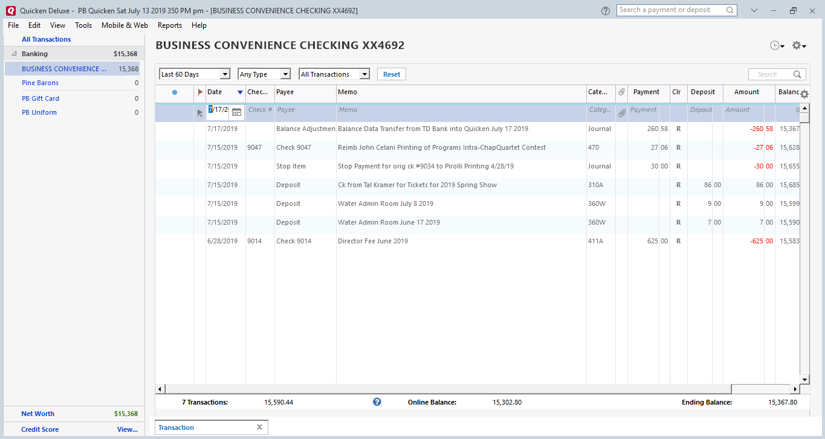

However, note that the July 17, 2019 data transfer from TD into Quicken resulted in Quicken not receiving 5 check entries plus 6 deposit entries that appear in TD and appear on our TD Bank statements for May and June 2019.

Even if I manually entered into Quicken the below listed 11 transactions, the balance between TD Bank and Quicken will still be off.

|  |  |  |  |  |
| --- | --- | --- | --- | --- |
|  | Debits |  |  |  |
| Date | Check # | Amt | Paid to | Budget Code |
| 3-Jun | 9044 | 625.00 | Rich Gray Director's Fees May 2019 | 411 |
| 3-Jun | 9043 | 226.44 | Reimb Rich Gray Hotel Fees Div Contest | 411 |
| 4-Jun | 9046 | 156.93 | Reimb Jim Scollay 21 Name Badges | 470 |
| 10-Jun | 9042 | 37.00 | Reimb Mike Thornton purch one Tix Div Dan Little | 421 |
|  |  |  |  |  |
| 16-May | 9041 | 120.00 | Cash to Rich Gray food per diem 2 days contest | 411 |
|  |  |  |  |  |
|  |  |  |  |  |
|  | Total | 1,165.37 |  |  |

|  |  |  |  |
| --- | --- | --- | --- |
|  | Credits |  |  |
| Date | Amt | Rcvd From | Budget Code |
| 10-Jun | 300.00 | Singout Woodland Baptist Church 5/25 | 320 |
| 10-Jun | 300.00 | Singout CH Twp Memorial Day 5/27 | 320 |
| 10-Jun | 41.00 | Chapter Share 50/50 6/8 Chaitlain won | 360R |
| 10-Jun | 20.00 | Water Admin 6/3 | 360W |
| 10-Jun | 10.00 | Singing Valentine Candy Sale 6/3 | 350D |
| 20-May | 300.00 | Singout Haddon Htgs Sat May 11 | 320 |
|  |  |  |  |
| 20-May | 37.00 |  |  |
| Total | 1,008.00 |  |  |

|  |  |  |  |  |
| --- | --- | --- | --- | --- |
|  |  | Diff | -157.37 |  |
|  |  |  |  |  |
|  | Bal Adjust July 17 | | -260.58 |  |
|  |  |  |  |  |
|  |  | Diff | 103.21 |  |
|  |  |  |  |  |

My intention was get “clean” data in Quicken before attempting a transfer of our Quicken data into Quick Books.

At this point, I am inclined to just perform a transfer of our Quicken data into Quick Books and hopefully the first data transfer from TD into Quick Books will be accurate, or at least significantly more accurate that the data transfers we have experienced in 2019 ever since we had to upgrade from Quicken 2016 to Quicken 2019.