April 30 2019 sign up NJ Family First Program

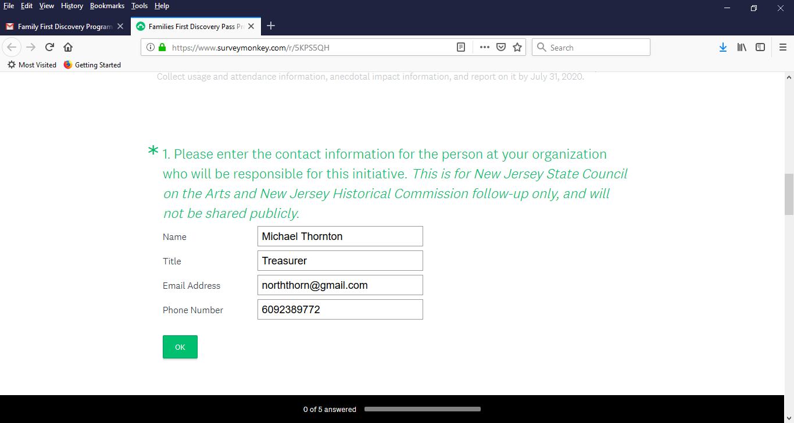

Please note: your responses to questions two through four WILL be posted as is on a public website advertising the Families First Discovery Pass.

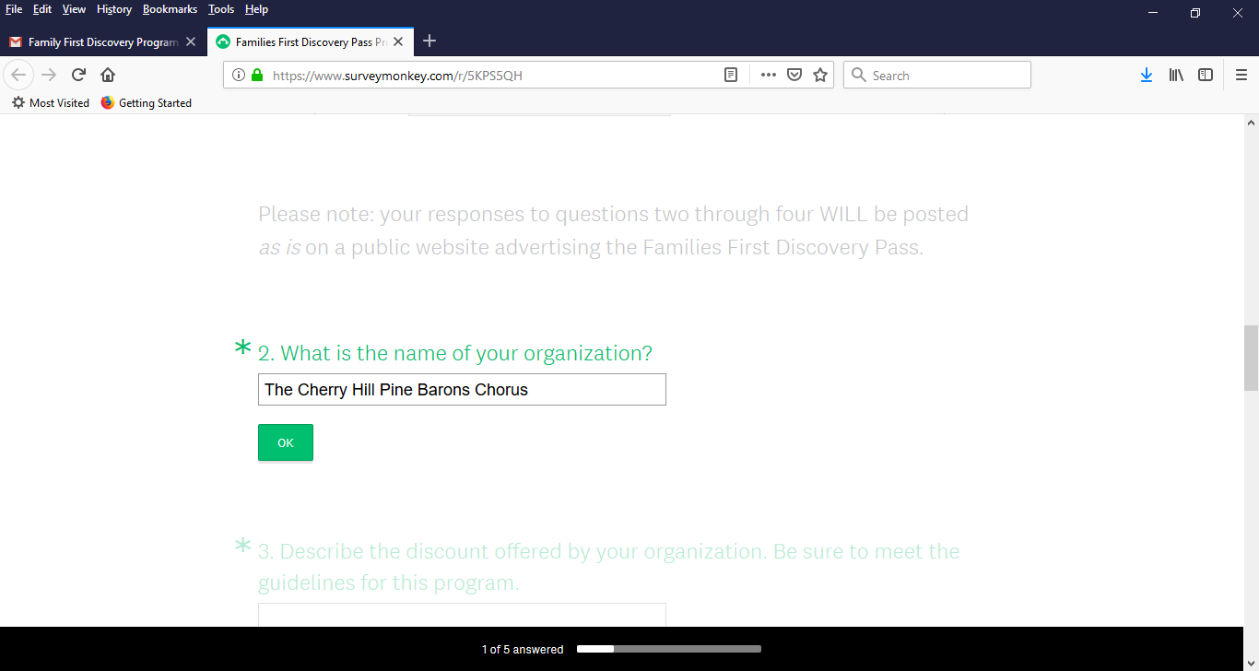

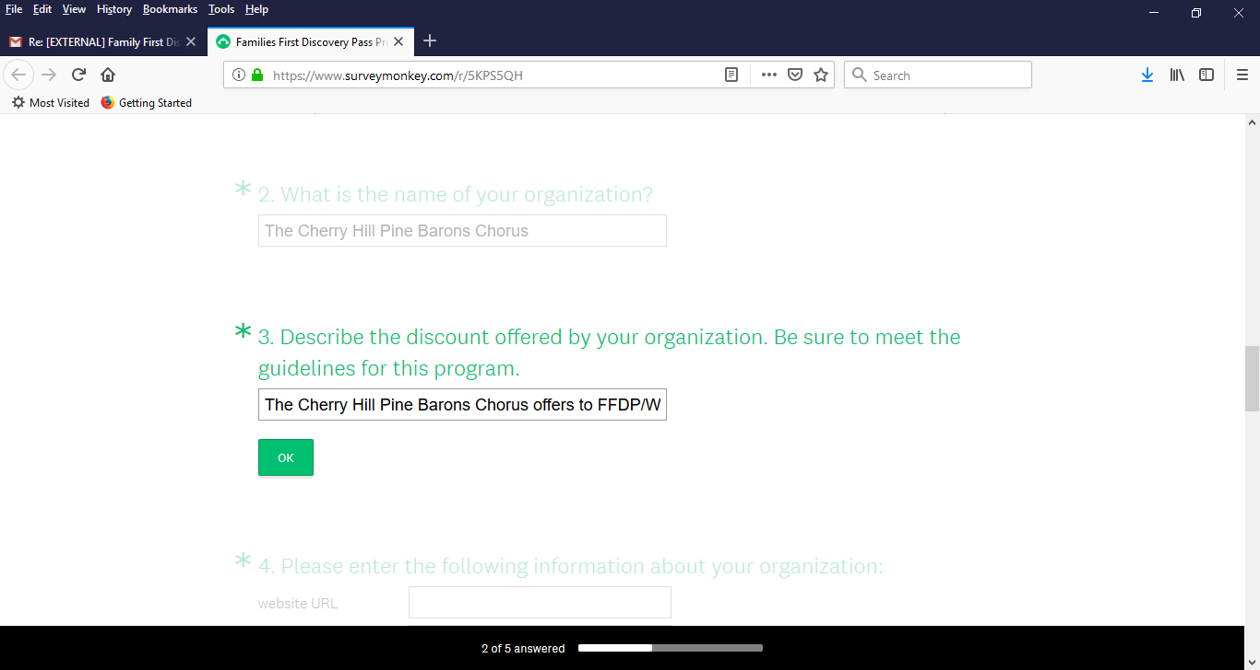

The Cherry Hill Pine Barons Chorus offers to FFDP/WIC holders a $10.00 discount off of regular advance or door ticket prices; youth 17 and under are free. This applies to our Annual Spring Show and to the evening performance of our December Holiday Show. Limit four family members per pass. Check our website for dates and times.

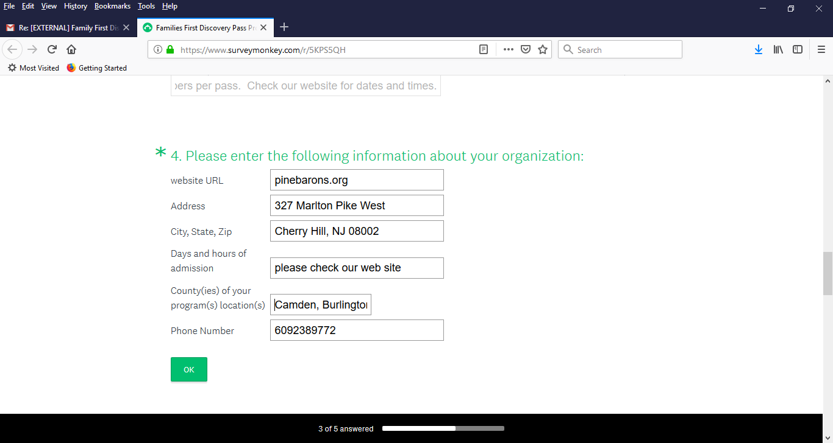

counties: Camden, Burlington, Gloucester

